Grace Presbyterian Church
7434 Bath Street
Springfield, Virginia 22150

Live-Streamed Worship

August 23, 2020

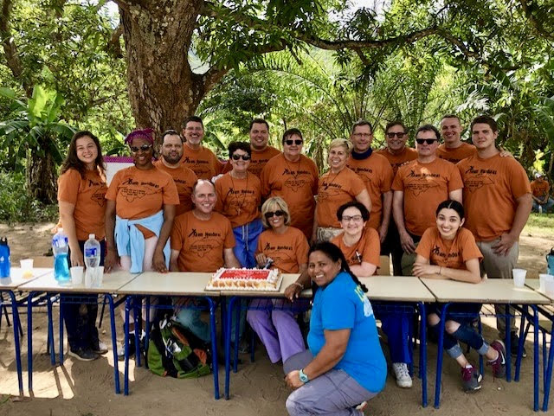

Greeting
Our Graduates

Lighting of the Peace Candle

Call to Worship (From Psalm 146)

One: Praise the Lord! Praise the Lord, O my soul!
Many: I will praise the Lord as long as I live;
I will sing praises to my God all my life long.
One: Let us worship God!
Hymn/Video Montage #69 Schutte

Here I Am, Lord

I, the Lord of sea and sky, I have heard my people cry.
All who dwell in dark and sin my hand will save.
I, who made the stars of night, I will make their darkness bright.
Who will bear my light to them? Whom shall I send?

Refrain Here I am, Lord. Is it I, Lord? I have heard you calling in the night.
I will go, Lord, if you lead me. I will hold your people in my heart.

I, the Lord of snow and rain, I have borne my people’s pain.
I have wept for love of them. They turn away.
I will break their hearts of stone, give them hearts for love alone.
I will speak my word to them. Whom shall I send?

(Refrain)

I, the Lord of wind and flame, I will tend the poor and lame.
I will set a feast for them. My hand will save.
Finest bread I will provide till their hearts be satisfied.
I will give my life to them. Whom shall I send?

(Refrain)

©1981, 2000, OCP. All rights reserved.
Reprinted with permission under ONE LICENSE #735028-A . All rights reserved.

Prayer of Confession

God of all people, we often think that our experience of the world is the only experience or the “right” experience. We become blind to the needs, the priorities, the lives of others. We fail to see you in our neighbors, with their gifts of beauty, wisdom, and love.

We also fail to see their needs, hurts, or challenges as any of our responsibility or concern. We have much to give, and to teach, O God, but also much to receive and to learn. Break down the symbolic walls we build to protect ourselves. Cut through our prejudices and our assumptions. Open us in new ways to you, and to the neighbors we encounter in you.

In Christ’s name we pray, Amen.

Assurance of forgiveness

Leader: The mercy of the Lord is from everlasting to everlasting. As far as the East is from the West, so far has God removed our transgressions from us. In Jesus Christ, we are all forgiven.

People: Thanks be to God!

Video Greeting John and Ericca Stryker

Scripture Reading 1 Corinthians 13:1-13

Video Reflections Heather Potter, Alem Bryant, Abby Bryant

Hymn #727 Gillard
Will You Let Me Be Your Servant (verses 1-4,6)

Will you let me be your servant, let me be as Christ to you?
Pray that I may have the grace to let you be my servant too.

We are pilgrims on a journey; we’re together on the road.
We are here to help each other walk the mile and bear the load.

I will hold the Christlight for you in the nighttime of your fear.
I will hold my hand out to you, speak the peace you long to hear.

I will weep when you are weeping; when you laugh I’ll laugh with you.
I will share your joy and sorrow till we’ve seen this journey through.

Will you let me be your servant, let me be as Christ to you?
Pray that I may have the grace to let you be my servant too.

© 1977 Universal Music - Brentwood Benson Publishing. All rights reserved. Used by permission.
Reprinted with permission under ONE LICENSE #735028-A. All rights reserved.

Children’s Sermon Judy Smith

Video Reflection Cindi Bryant

Update on HOI Ministries Pastor Selvin
Prayers of the People

(Please submit your joys and concerns online.)

An Offering of Gratitude Joe and Greta Miller

Prayer of Dedication

Video Reflection Kay Pickett, mother of Cindi Bryant

Parting Hymn #716 Edwards

God, Whose Giving Knows No Ending

God, whose giving knows no ending, from your rich and endless store,
Nature’s wonder, Jesus’ wisdom, costly cross, grave’s shattered door:
Gifted by you, we turn to you, offering up ourselves in praise;
Thankful song shall rise forever, gracious donor of our days.

Skills and time are ours for pressing toward the goals of Christ, your Son:
All at peace in health and freedom, races joined, the church made one.
Now direct our daily labor, lest we strive for self alone.
Born with talents, make us servants fit to answer at your throne.

Treasure, too, you have entrusted, gain through powers your grace conferred:
Ours to use for home and kindred, and to spread the gospel word.
Open wide our hands in sharing, as we heed Christ’s ageless call,
Healing, teaching, and reclaiming, serving you by loving all.

© 1961, ren. 1989 The Hymn Society (admin. Hope Publishing Co.) All rights reserved. Used by permission.
Reprinted with permission under ONE LICENSE #735028-A. All rights reserved.

Benediction

Response #541

God Be with You Till We Meet Again

God be with you till we meet again; Loving counsels guide, uphold you,
With a shepherd's care enfold you: God be with you till we meet again.

