Grace Presbyterian Church
7434 Bath Street
Springfield, Virginia 22150

Live-Streamed Worship
May 17, 2020

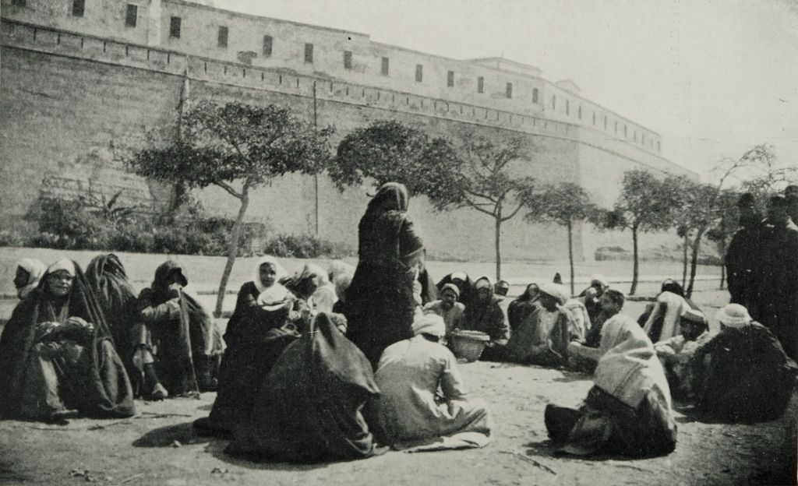

Greeting

Lighting of the Peace Candle

Call to Worship (Based on Psalm 66:16-20)

One Voice: Come and hear, and I will tell what God has done for me.
Many Voices: I cried aloud to God, and praised God with my tongue.
One Voice: God truly has listened;
Many Voices: God has given heed to the words of my prayer.
One Voice: Blessed be God,
Many Voices: For God’s steadfast love has been with me.

Musical Offerings

Amazing Grace Shane Hatfield, bass

Swing Low, Sweet Chariot Ainsley Hawkins, piano
Prayer of Confession

Gracious God, we become forgetful. We forget how much you love us and how much we are called to love. We forget to be patient or kind. We forget that you sustain us and we become anxious. We forget sympathy and empathy, becoming wrapped in our own concerns. We forget the power of gentleness and generosity. God of understanding, forgive us. Restore us. Create in us a clean heart and renew a right spirit within us, that we may see your image in ourselves and in our neighbors, and heed the call of your kingdom. Amen

Assurance of Pardon

Leader: The mercy of the Lord is from everlasting unto everlasting. God’s mercies are new every morning. By the grace of Jesus Christ and the power of the Holy Spirit, we are made new and given strength to love and serve. Hear the good news and be at peace.
People: Thanks be to God.

Children’s Sermon

Scriptures that Sustain Psalm 119:11 and Philippians 4:6-8 Kim Hatfield

Hymn #463 How Firm a Foundation

How firm a foundation, ye saints of the Lord,
Is laid for your faith in God’s excellent Word!
What more can be said than to you God hath said,
To you who for refuge to Jesus have fled?

“Fear not, I am with thee, O be not dismayed,
For I am thy God, and will still give thee aid;
I’ll strengthen thee, help thee, and cause thee to stand,
Upheld by my righteous, omnipotent hand.

“When through the deep waters I call thee to go,
the rivers of sorrow shall not overflow;
For I will be near thee, thy troubles to bless,
And sanctify to thee thy deepest distress.

“When through fiery trials thy pathway shall lie,
My grace, all sufficient, shall be thy supply;
The flame shall not hurt thee; I only design
Thy dross to consume, and thy gold to refine.

“The soul that on Jesus hath leaned for repose,
I will not, I will not desert to its foes;
That soul, though all hell should endeavor to shake,
I’ll never, no, never, no, never forsake.”
Scriptures that Sustain

1 Corinthians 13:12 Tim and Susan Stryker

Matthew 5:4 JoAnn Holmes

Hymn #172

Blest Are They

Blest are they, the poor in spirit; theirs is the kingdom of God.
Blest are they, full of sorrow; they shall be consoled.

(Refrain) Rejoice and be glad! Blessed are you; holy are you!
Rejoice and be glad! Yours is the kingdom of God.

Blest are they, the lowly ones; they shall inherit the earth.
Blest are they who hunger and thirst; they shall have their fill. (Refrain)

Blest are they who show mercy; mercy shall be theirs.
Blest are they, the pure of heart; they shall see God. (Refrain)

Blest are they who seek peace; they are the children of God.
Blest are they who suffer in faith; the Glory of God is theirs. (Refrain)

Blest are you who suffer hate, all because of me.
Rejoice, be glad; yours is the kingdom; shine for all to see. (Refrain)

Scriptures that Sustain Psalm 116 Jim Drinkard

Offering

(A word about ways to support Grace’s ministry)

Prayer of Dedication

Prayers of the People/The Lord’s Prayer

(Please submit your joys and concerns online.)

Parting Hymn #840 It Is Well with My Soul

When peace like a river attendeth my way,
When sorrows like sea billows roll,
Whatever my lot, thou hast taught me to say,
It is well; it is well with my soul.

(Refrain) It is well (It is well) with my soul (with my soul);
It is well; it is well with my soul.

Though Satan should buffet, though trials should come,
Let this blest assurance control,
That Christ hath regarded my helpless estate,
And hath shed his own blood for my soul. (Refrain)

He lives: O the bliss of this glorious thought.
My sin, not in part, but the whole,
Is nailed to the cross and I bear it no more.
Praise the Lord, praise the Lord, O my soul! (Refrain)

Lord, hasten the day when our faith shall be sight,
The clouds be rolled back as a scroll,
The trumpet shall sound and the Lord shall descend;
Even so it is well with my soul. (Refrain)

Benediction

Response 541

God Be with You Till We Meet Again

God be with you till we meet again; Loving counsels guide, uphold you,
With a shepherd's care enfold you: God be with you till we meet again.

The background art on our slides today was made by Avery Jacobs.

