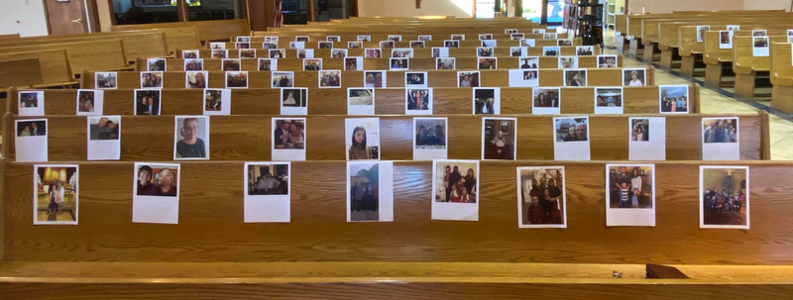

Grace Presbyterian Church
7434 Bath Street
Springfield, Virginia 22150

Live-Streamed Worship
May 3, 2020

Welcome and Announcements

Lighting of the Peace Candle

Call to Worship

(Adapted from Spiritual Hunger and Thirst for God, by Rev. Bonnie Tarwater)

One: God of healing and transformation,
we hunger and thirst for your abundant life.
Many: We bring you our sorrow and ask for the bread of joy;
we bring you our despair and ask for the bread of hope;
we bring you our weariness and ask for the bread of inspiration.
One: Meet us here in our hunger and in our hope.
Many: We need the bread of heaven to sustain us
as we journey to find our way,
that we may be one with you.
One: Let us worship God.
Hymn #79

Light Dawns on a Weary World

Light dawns on a weary world
When eyes begin to see all people’s dignity.
Light dawns on a weary world: the promised day of justice comes.

[Refrain] The trees shall clap their hands; the dry lands gush with springs;
The hills and mountains shall break forth with singing!
We shall go out in joy, and be led forth in peace,
As all the world in wonder echoes shalom.

Love grows in a weary world
When hungry hearts find bread and children’s dreams are fed.
Love grows in a weary world: the promised feast of plenty comes.

(Refrain)

Hope blooms in a weary world
When creatures, once forlorn, find wilderness reborn.
Hope blooms in a weary world: the promised green of Eden comes.

(Refrain)

Prayer of Confession (Based on Psalm 51)

One: Create in us clean hearts, O God, open and receptive to your Spirit.
Many: Create in us clean hearts, O God, washed clean from bitter thoughts, from shame, guilt, envy, and anger.
One: Create in us clean hearts, O God, free from anxiety about the past or the future, confident in the presence of your Holy Spirit, and in your gift of peace.
Many: Create in us clean hearts, O God, cleansed by your mercy,
and made strong by your love.
One: Create in us clean hearts, O God.
Many: Create in us clean hearts, O God,
and put a new and right spirit within us.

Assurance of Forgiveness

Leader: The mercy of the Lord is from everlasting unto everlasting. As far as the East is from the West, so far has God removed our transgression from us. In the name of Jesus Christ, we are all forgiven.
People: Thanks be to God.
Anthem Shelter Me:
(A Prayer-Song in the Time of the COVID-19 Pandemic)

Performed by Young Voices of the Philippines
Composed by Jan Michael Joncas
Used by permission.

Children’s Sermon

Scripture Lesson Exodus 16:2-5, 13-21, 35

Hymn #509
All Who Hunger, Gather Gladly

All who hunger, gather gladly: holy manna is our bread.
Come from wilderness and wandering. Here, in truth, we will be fed.
You that yearn for days of fullness, all around us is our food.
Taste and see the grace eternal. Taste and see that God is good.

All who hunger, never strangers, seeker, be a welcomed guest.
Come from restlessness and roaming. Here, in joy, we keep the feast.
We that once were lost and scattered in communion’s love have stood.
Taste and see the grace eternal. Taste and see that God is good.

All who hunger, sing together; Jesus Christ is living bread.
Come from loneliness and longing. Here, in peace, we have been led.
Blest are those who from this table live their days in gratitude.
Taste and see the grace eternal. Taste and see that God is good.

Scripture Lesson Luke 4:1-4; Luke 9:10-17

Sermon Manna in the Morning Rev. Dr. Ben Trawick

Offering A word about ways to support Grace’s ministry

Hymn #501
Feed Us, Lord

Feed us, Lord. Feed us, Lord.
In the broken bread, be revealed again.
Come and feed our hearts, O Lord.

Quench us, Lord. Quench us, Lord.
On this thirsty ground, may your love flow down.
Come and quench our hearts, O Lord. (Continued)
Fill us, Lord. Fill us, Lord,
With the bread and wine of the risen Christ.
Come and fill our hearts, O Lord.

Lead us, Lord. Lead us, Lord,
Nourished here by Christ, given strength for life.
Come and lead our hearts, O Lord.

Sacrament of the Lord’s Supper

Prayers of the People/The Lord’s Prayer

Parting Hymn #822
When We Are Living

When we are living, it is in Christ Jesus,
And when we’re dying it is in the Lord.
Both in our living and in our dying
We belong to God; we belong to God.

Through all our living, we our fruits must give.
Good works of service are for offering.
When we are giving, or when receiving,
We belong to God; we belong to God.

‘Mid times of sorrow and in times of pain,
When sensing beauty or in love’s embrace,
Whether we suffer, or sing rejoicing,
We belong to God; we belong to God.

Across this wide world, we shall always find
Those who are crying with no peace of mind,
But when we help them, or when we feed them,
We belong to God; we belong to God.

Benediction

Response 541
God Be with You Till We Meet Again

God be with you till we meet again;
Loving counsels guide, uphold you,
With a shepherd's care enfold you:
God be with you till we meet again.

