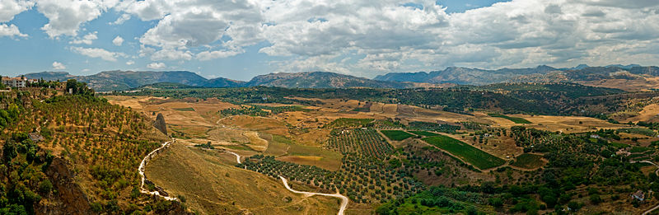

*Wikimedia Commons*

Grace Presbyterian Church

7434 Bath Street

Springfield, Virginia 22150

**Live-Streamed Worship**

**April 26, 2020**

Greeting

Lighting of the Peace Candle

Call to Worship

Leader: We live in the shelter of God’s good creation and we dwell amid God’s wondrous, living work of art.

People: We rejoice that the Earth is the Lord’s and God’s Earth is our home.

Leader: Upon this Earth and amid God’s creation, we are not alone. We share life with the waters and the land, with grasses and trees, meadows and mountains;

People: With fish, birds, animals, and insects, creatures of every form, and with all our brothers and sisters.

Leader: God is good and all that God has created, God has called very good.

People: God is love and everything God makes is love’s fruit.

Leader: Let us worship God!

Hymn #36

*For the Fruit of All Creation*

For the fruit of all creation, thanks be to God.

For the gifts to every nation, thanks be to God.

For the plowing, sowing, reaping, silent growth while we are sleeping,

Future needs in earth’s safekeeping, thanks be to God.

In the just reward of labor, God’s will be done.

In the help we give our neighbor, God’s will be done.

In our worldwide task of caring for the hungry and despairing,

In the harvests we are sharing, God’s will be done.

For the harvests of the Spirit, thanks be to God.

For the good we all inherit, thanks be to God.

For the wonders that astound us, for the truths that still confound us,

Most of all that love has found us, thanks be to God.

*The Prayer of Confession and Assurance of Pardon*

*are by Allen Brimer, McCormick Seminary.*

Scripture Reading *(From Hosea 4:1-3)*

There is no loyalty or faithfulness, and no knowledge of God in the land. Swearing, stealing, lying, murder, and adultery break out; bloodshed follows bloodshed. The land mourns, and all who live in it languish; together with the wild animals and the birds of the air, even the fish of the sea are perishing.

Prayer of Confession *(Together)*

Merciful God, in your gracious presence, we confess our sin and the sin of this world. Although Christ is risen from the grave and has shattered the power of death, we are still held captive by fear and doubt. We hold on to suspicions and jealousies that set neighbor against neighbor and nation against nation. We have neglected the poor and the hungry. In our pursuit of the “good life”, we have gone along with injustice, we have ignored the cries of the oppressed. We pursue profits and pleasures that harm the land and pollute the waters. We have squandered the Earth’s gifts on technologies of destruction. Have mercy on us, O God. Help us to trust your power to change our lives and make us new, that we and all your creatures may know the joy of life abundant, given through Jesus Christ, the risen Lord. Amen.

Assurance of Forgiveness

Leader: The good news is that Christ calls us to new life and enables us to begin again and again and again and again. Friends, believe the good news of the Gospel: In Jesus Christ we are forgiven!

All: Thanks be to God.

Children’s Sermon

Scripture Lesson Genesis 2:4b-25

Hymn #22

*God of the Sparrow*

God of the sparrow, God of the whale, God of the swirling stars,

How does the creature say Awe? How does the creature say Praise?

God of the earthquake, God of the storm, God of the trumpet blast,

How does the creature cry Woe? How does the creature cry Save?

God of the rainbow, God of the cross, God of the empty grave,

How does the creature say Grace? How does the creature say Thanks?

God of the hungry, God of the sick, God of the prodigal,

How does the creature say Care? How does the creature say Life?

God of the neighbor, God of the foe, God of the pruning hook,

How does the creature say Love? How does the creature say Peace?

God of the ages, God near at hand, God of the loving heart,

How do your children say Joy? How do your children say Home?

Scripture Lesson Psalm 8:1-9

Sermon *Web of Wonder* Rev. Dr. Ben Trawick

Offering A word about ways to support Grace’s ministry

Prayer of Dedication

An Easter Greeting from our Friends in Nablus

Prayers of the People and The Lord’s Prayer

(Please submit your joys and concerns online.)

Parting Hymn #77

*Isaiah the Prophet has Written of Old*

Isaiah the prophet has written of old

How God’s new creation shall come.

Instead of the thorn tree, the fir tree shall grow;

The wolf shall lie down with the lamb.

The mountains and hills shall burst forth into song,

The peoples be led forth in peace,

For the earth shall be filled with the knowledge of God

As the waters cover the sea.

Yet nations still prey on the meek of the world,

And conflict turns parent from child.

Your people despoil all the sweetness of earth;

The briar and the thorn tree grow wild.

God, bring to fruition your will for the earth,

That no one shall hurt or destroy,

That wisdom and justice shall reign in the land

And your people shall go forth in joy.

Benediction

Response 541

*God Be with You Till We Meet Again*

God be with you till we meet again;

Loving counsels guide, uphold you,  
With a shepherd's care enfold you:

God be with you till we meet again.